Faculty of Engineering Sciences and Technology

Activity # 01

Course: | Final Year Project 1 | Coordinator: | Dr. Atiya Masood
Marks Allocated  : | 10 Marks | Time Allocated: | 1 Week
CLO  Allocated  : | CLO-1 (BT Level- C3), CLO-2 (BT Level- C4), CLO-8 (BT Level- A2)  and CLO – 10 (BT Level- A1) | PLO  Allocated: | PLO1- Engineering Knowledge, PLO2- Problem Analysis, PLO 10- Communication and PLO11- Project Management

A. Project Title: Skintelli: Intelligent Skin Disease Detection System with Explainable AI
B. Funding / Sponsoring Organization (if any): None
C. Project Start Date: 06 October 2025
D. Project Finish Date: 21st June 2026
E. Project Summary (200 - 300 words):
Skintelli addresses a critical healthcare gap in Pakistan, where only around 1,200 dermatologists serve the entire population, with extremely limited access in rural areas. High consultation fees, lack of awareness, and inability to distinguish between dangerous and harmless skin lesions result in delayed treatment of serious conditions like melanoma. Additionally, current AI diagnostic systems lack transparency, making it difficult for patients to trust their predictions.
This project proposes a desktop application that combines advanced computer vision with explainable AI to provide transparent and accessible skin disease screening. Skintelli integrates YOLOv8 for rapid and accurate skin lesion detection and classification, Grad- CAM for generating visual heatmaps that highlight the AI's focus areas, and a Large Language Model (LLM) with Retrieval-Augmented Generation (RAG) to provide clear, natural language explanations backed by updated medical knowledge. An agentic AI workflow automates the entire process from image input to final diagnostic report.
The key innovation of Skintelli is transparency—users can see exactly which parts of the skin lesion the AI examined before making its classification decision. The dual-panel interface displays the original image alongside the AI-generated heatmap, while the LLM provides easy-to-understand explanations of findings. The system works completely offline, making it suitable for areas with limited internet connectivity. By targeting over 90% accuracy with processing times under 5 seconds, Skintelli
aims to serve as a preliminary screening assistant, helping users determine whether they should seek professional dermatological consultation, ultimately reducing late-stage diagnoses of serious skin conditions.

F. Objectives, Benefits, and Deliverables
- Objectives
  - Develop Accurate Skin Lesion Detection
    - Create a YOLOv8-based model capable of detecting and classifying skin lesions with >90% accuracy in under 5 seconds, providing reliable preliminary screening results.

Implement Explainable AI Features
    - Integrate Grad-CAM visualization to generate clear heatmaps showing which image regions influenced the AI's decision, addressing the "black box" problem.

Provide Accessible Natural Language Explanations
    - Utilize an LLM with RAG to generate user-friendly, medically accurate explanations of detected skin conditions in natural language for non-medical users.

Create Transparent Diagnostic Workflow
    - Build an agentic AI system that automates the diagnostic process from image input to classification and final explanation, maintaining transparency at every step.

Ensure Offline Functionality
    - Develop a desktop application that works without internet connectivity, making it accessible in rural and remote areas.

Benefits
  - Improved Healthcare Access
    - Provides preliminary skin disease screening in areas with limited access to dermatologists, benefiting rural populations in Pakistan.

Early Detection of Serious Conditions
    - Helps users identify potentially dangerous lesions early, reducing late-stage diagnoses of conditions like melanoma through timely referral to specialists.

Increased Trust Through Transparency
    - Visual heatmaps and natural language explanations help users understand and trust AI decisions, mitigating concerns about "black box" AI systems.

Cost-Effective Screening
    - Offers a free preliminary screening tool, helping users decide whether expensive dermatologist consultations are necessary, reducing financial barriers.

Educational Value
    - Provides information about skin conditions, increasing health literacy and awareness.

Time-Efficient Processing
    - Delivers results in under 5 seconds, enabling quick screening in clinical or community health settings.

Deliverables
  - Trained YOLOv8 Model
    - Fully trained and fine-tuned model achieving >90% accuracy on skin lesion detection and classification using HAM10000 and ISIC datasets.

Desktop Application
Functional software with intuitive GUI, supporting both camera capture and image upload options.

Explainable AI Module
    - Integrated Grad-CAM functionality generating color-coded heatmaps highlighting the AI's decision-making process.

LLM-Powered Explanation System
    - Natural language explanation generator powered by LLM and RAG, providing clear and medically accurate descriptions of detected conditions.
  - Comprehensive Documentation
    - Includes user manual, system architecture documentation, source code with comments, and installation guide.
  - Performance Report
    - Detailed evaluation with accuracy metrics, processing time measurements, test results, and comparative analysis against baseline models.

F. Plan:

Development / Research Methodology
- Introduction
The development of medical AI applications requires a structured approach to ensure accuracy, reliability, and user trust. For the Skintelli project, which aims to provide transparent skin disease detection through explainable AI, a systematic methodology is essential. This section outlines the chosen methodology, its applicability to Skintelli, key technical components, and justification for its selection.

Waterfall Methodology Overview
The Waterfall Model is a traditional, linear-sequential approach where progress flows downward through distinct phases:
  - Conception
  - Initiation
  - Requirement Analysis
  - Design
  - Implementation (Construction)
  - Testing
  - Deployment
  - Maintenance

Key Features of Waterfall:
    - Each phase is completed before moving to the next.
    - Emphasis on documentation at every stage.
    - Suitable for projects with well-defined requirements, like academic FYPs.

Applicability to Skintelli
The Waterfall Model suits Skintelli due to:
- Clear Scope: Core features and objectives (YOLOv8, Grad-CAM, LLM+RAG) are predefined.
- Structured Phases: Allows clear milestones aligned with FYP requirements.

- Documentation Focus: Ensures transparency and traceability—critical for medical AI.
- Sequential Nature: Helps student teams manage tasks and solidify foundational work before coding.
- Predictable Timeline: Facilitates accurate resource allocation and project planning.

Key Features to Develop
Using the Waterfall approach, the project will develop:
  - YOLOv8 Skin Lesion Detection Model: Real-time detection and classification using dermatology datasets (HAM10000, ISIC).
  - Grad-CAM Visual Explanation System: Heatmaps showing image regions influencing AI decisions.
  - LLM-Powered Natural Language Explanations: RAG-enabled language model for context-aware medical explanations.
  - Agentic AI Workflow: End-to-end automated pipeline from image input to results display.
  - Dual-Panel Desktop Interface: Displays original images alongside AI- generated heatmaps and text explanations.
  - Offline Functionality: Operates without internet connectivity for rural healthcare accessibility.

Principles/Phases of the Waterfall Model
- Sequential Progression: Complete one phase before moving on.
- Documentation-Driven: Detailed deliverables at each stage.
- Clear Milestones: Each phase has approval checkpoints.
- Formal Reviews: Ensure completeness and correctness.
- Limited Flexibility: Changes are difficult post-phase, emphasizing early planning.

High-Level Process Flow
Phase 1: Requirement Elicitation & Analysis
- Stakeholder discussions (patients, healthcare workers)
- Analyze the problem domain (skin disease detection in Pakistan)
- Define technical requirements (accuracy, processing time, explainability)

- Document all requirements in SRS

Establish success criteria and acceptance metrics Phase 2: System & Software Design
- System architecture (YOLOv8, Grad-CAM, LLM+RAG)
- UI/UX design for dual-panel interface
- Define data flow from input → detection → explanation → output
- Design module specifications and integration points
- Create medical knowledge database for RAG system

Phase 3: Implementation & Unit Testing
- Dataset Preparation: Cleaning, preprocessing, augmentation, splitting
- YOLOv8 Training: Model development, hyperparameter tuning, optimization
- Grad-CAM Integration: Implement heatmaps, ensure quality
- LLM+RAG Setup: Connect language model with knowledge base
- Agentic AI Workflow: Automate pipeline, error handling
- GUI Development: Desktop interface with camera/file upload
- Unit Testing: Test individual components

Phase 4: Integration & System Testing
- Integrate all modules into a complete system
- Conduct integration testing for component communication
- System testing: Validate end-to-end functionality
- Performance testing: Ensure >90% accuracy, <5 sec processing
- User Acceptance Testing (UAT): Evaluate usability and explanation clarity
- Document all results and issues

Phase 5: Deployment & Maintenance
- Fix bugs and optimize performance
- Prepare final desktop application package
- Create user manual and technical documentation
- Compile final project report
- Prepare demonstration script and presentation materials

Justification for Choosing Waterfall
- Clarity & Structure: Easy to plan, manage, and track progress
- Documentation-Oriented: Aligns with FYP reporting standards
- Predictable Progression: Defined scope allows accurate timelines
- Reduced Ambiguity: Ensures requirements and design are solid before implementation
- Risk Mitigation: Identifies challenges early in planning
- Quality Assurance: Formal reviews maintain high quality

Conclusion
The Waterfall Model provides a robust framework for Skintelli’s development. Its sequential phases, focus on documentation, and structured approach are ideal for a Final Year Project. Following this methodology ensures the systematic development of all key features, resulting in a transparent, reliable, and functional AI application to address Pakistan’s dermatological healthcare accessibility challenges.

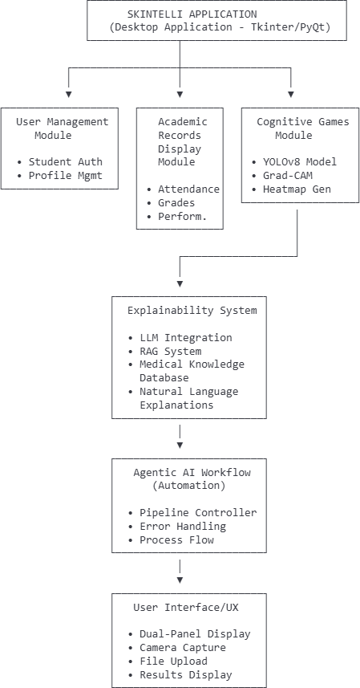
- System Architecture Diagram:

System Architecture of Skintelli
The Skintelli system architecture is a multi-layered design created to provide transparent and explainable skin disease detection. It integrates AI-powered detection, visual explanations, and natural language explanations in a structured pipeline.

User Interface Layer
  - Technology: Tkinter / PyQt
  - Function: Front-end interface for user interaction

Modules:
    - Image Input Module: Supports camera capture and file upload
    - Results Display Module: Dual-panel display showing:
      - Original skin lesion images
      - AI-generated Grad-CAM heatmaps

Agentic AI Workflow Engine
  - Role: Central orchestrator of the diagnostic pipeline

Responsibilities:
    - Manages flow between system components
    - Automates end-to-end image processing and explanation generation
    - Handles errors and exceptions to ensure robust operation

YOLOv8 Detection Model
  - Core AI Engine: Trained on HAM10000 and ISIC dermatology datasets

Function:
    - Detects and classifies skin lesions
    - Produces classification results with confidence scores
  - Feature: Optimized for rapid detection and high accuracy

- Explainability Module
  - Technique: Grad-CAM (Gradient-weighted Class Activation Mapping)
  - Purpose:
    - Generates heatmaps highlighting regions influencing AI decisions
    - Addresses the “black box” problem in AI-based diagnosis
  - Output: Visual explanation to improve user trust

LLM + RAG Explanation System
  - Components: Large Language Model + Retrieval-Augmented Generation (RAG)
  - Purpose: Converts AI outputs into clear, user-friendly natural language explanations

Functionality:
    - Accesses a medical knowledge database
    - Ensures medically accurate and context-aware explanations

Data Layer
  - Foundation of the System:
    - Training Datasets: HAM10000, ISIC Archive
    - Medical Knowledge Base: Used by the RAG system to generate accurate textual explanations

Summary
The integrated architecture ensures that Skintelli:
  - Detects skin conditions accurately
  - Provides visual explanations via Grad-CAM
  - Delivers textual explanations using LLM + RAG
  - Offers a user-friendly interface for accessible AI-powered healthcare
This architecture makes Skintelli a comprehensive, transparent, and trustworthy medical AI system.

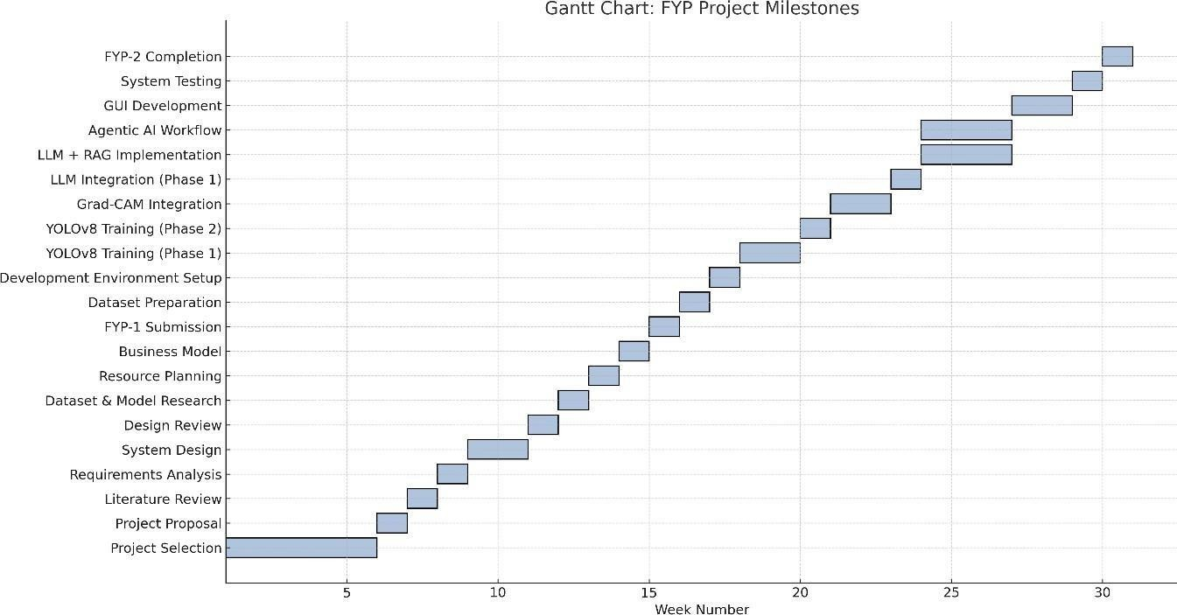
G. Project Schedule / Milestone Chart Gantt Chart:

H. Key Milestones of the Project / Project Management:
No. | Duration | Milestone | Key Deliverables
1 | Week 1–5 | Project Selection | Approval of Skintelli concept, problem statement, and objectives.
2 | Week 6 | Project Proposal | Submission of detailed proposal document.
3 | Week 7 | Literature Review | Report on existing skin disease detection systems and explainable AI approaches.
4 | Week 8 | Requirements Analysis | Software Requirements Specification (SRS) covering functional and non-functional needs.
5 | Week 9-10 | System Design | UI prototypes for dual-panel display, system architecture, and model pipeline design.
6 | Week 11 | Design Review | Evaluation of design and finalization of scope.
7 | Week 12 | Dataset & Model Research | Findings on HAM10000 and ISIC datasets, YOLOv8 architecture study.
8 | Week 13 | Resource Planning | Finalized resource allocation and budget.

9 | Week 14 | Business Model | Lean Canvas, poster content, and presentation plan.
10 | Week 15 | FYP-1 Submission | Final report for Phase 1.
11 | Week 16 | Dataset Preparation | Cleaned and preprocessed HAM10000 and ISIC datasets with train/validation/test splits.
12 | Week 17 | Development Environment Setup | Python environment, YOLOv8, TensorFlow/PyTorch, and version control setup.
13 | Week 18–  19 | YOLOv8 Model Training (Phase 1) | Initial model training with baseline configuration.
14 | Week 20 | YOLOv8 Model Training (Phase 2) | Model fine-tuning and optimization for accuracy target (90%+).
15 | Week 21–  22 | Grad-CAM Integration | Explainability module with heatmap generation and visualization.
16 | Week 23 | LLM Integration (Phase 1) | Basic LLM setup and prompt engineering for explanations.
17 | Week 24–  26 | LLM + RAG  Implementation | Complete RAG system with medical knowledge database and context-aware explanations.
18 | Week 24-  26 | Agentic AI Workflow | Automated pipeline connecting detection, explanation, and display modules.
19 | Week 27-  28 | GUI Development | Desktop application with dual-panel interface, camera capture, and file upload functionality.
20 | Week 29 | System Testing | Unit, integration, and performance testing with bug fixes.
21 | Week 30 | FYP-2 Completion | Final report, demonstration, and presentation.

I. Final deliverable of the project (please tick one of the following)
□ Hardware system | □ Software system | □ HW/SW integrated system
□ Software simulation results | □ Comparative study | □ Mobile App
□ Web App | □ Other (please specify)
J. Equipment required for the project with Estimated Cost:
- Development Computer (Existing – Team members' laptops) Cost: PKR 0
- Google Colab Pro (Optional for faster GPU training) Cost: PKR 2,800 per month (OR PKR 0 if using free tier)

- Python 3.8+ (Free)
- YOLOv8 Framework (Free - Ultralytics)
- TensorFlow/PyTorch (Free)

- Grad-CAM Libraries (Free)

- OpenCV (Free)

- Tkinter/PyQt (Free)

- LLM API Access (Free tier or minimal cost) - PKR 0-1,000

- HAM10000 Dataset (Free - Public dataset)

- ISIC Archive Dataset (Free - Public dataset)

- USB Webcam (If needed for testing) - PKR 1,000-2,000 Estimated Total Cost: PKR 2,500 - 3,500

Estimated Cost: Minimal (primarily relying on existing hardware and free software tiers).

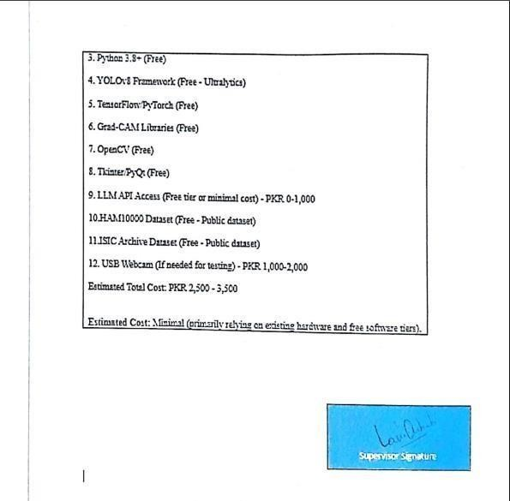

Faculty of Engineering Sciences and Technology
Activity # 02

Course: | Final Year Project 1 | Coordinator: | Dr. Atiya Masood
Marks Allocated: | 10 Marks | Time Allocated: | 10/12/2025
CLO  Allocated: | CLO-1 (BT Level- C3), CLO-2 (BT Level- C4), CLO-8 (BT Level- A2) and CLO – 12 (BT  Level- C6) | PLO  (GA)Allocated: | PLO1(GA1)- Engineering Knowledge, PLO2(GA2)- Problem Analysis, PLO 10(GA10)- Communication and PLO12(GA12)- Lifelong Learning

Introduction

This chapter examines the fundamental cha lenges in dermatological healthcare accessibility, particularly in resource- constrained regions like Pakistan, and explores how artificial inte ligence can address these gaps. It analyzes the critical need for explainable AI systems in medical diagnosis, where transparency and trust are paramount. The Skinte li platform—a desktop application leveraging YOLOv8, Grad-CAM, LLM, RAG, and Agentic AI—is positioned as a solution that not only detects skin diseases but also explains its reasoning in human-understandable terms. Following this, we review existing AI-based skin diagnosis systems, medical imaging tools, and explainable AI platforms to identify their strengths, limitations, and the unique value proposition that Skinte li brings to the field.

The Problem: Limited Dermatological Access and Lack of Trust in AI Diagnosis

For mi lions of patients across Pakistan and similar developing regions, access to dermatological expertise remains severely limited. With approximately 1,200 dermatologists serving a population of over 220 mi lion, the gap between healthcare demand and supply is alarming. This disparity is particularly acute in rural areas where specialist consultations may require extensive travel, time, and financial resources that many patients simply cannot afford.

Key aspects of the problem:
Severe Healthcare Inequality: Urban centers concentrate most dermatological expertise, leaving rural populations underserved. High consultation fees (often PKR 1,500-3,000 per visit) create financial barriers for low-income families who may delay seeking care until conditions become severe.
Delayed Diagnosis of Critical Conditions: Many patients cannot distinguish between benign lesions and potentia ly dangerous conditions like melanoma or basal ce l carcinoma. This lack of awareness, combined with

limited access, leads to late-stage diagnoses when treatment options become more limited and expensive.

The Black Box Problem in Medical AI: While AI systems have shown promising accuracy in skin disease detection, most operate as "black boxes"—providing diagnoses without explaining their reasoning. This lack of transparency creates trust issues among both patients and healthcare providers, who are reluctant to rely on systems they cannot understand or verify.
Information Gap for Self-Assessment: Patients lack accessible tools to conduct preliminary screenings at home. Without guidance, they either ignore potentia ly serious symptoms or rush to emergency care for benign conditions, straining healthcare systems.
Integration Challenges: Existing AI tools often require internet connectivity, complex technical knowledge, or integration with hospital systems—barriers that make them impractical for widespread community use in resource limited settings.
Need for a Comprehensive Solution: These interconnected cha lenges demonstrate the urgent need for an accessible, transparent, and trustworthy AI-based screening tool. Skinte li addresses this need through its explainable AI approach, dsigned specifica ly for the constraints and requirements of underserved populations.

The Solution: Skintelli – An Explainable AI System for Skin Disease Detection

Skinte li is a desktop application built using Python with integrated AI technologies including YOLOv8 for detection, Grad-CAM for visual explanations, and LLM with RAG for natural language understanding. It's carefu ly designed to bridge the gap between advanced medical AI and accessible, trustworthy healthcare screening for everyday users.
How Skintelli Addresses the Core Problems:

Advanced Detection with YOLOv8 (Object Detection Model):

What it does: YOLOv8 (You Only Look Once version 8) is a state-of-the-art real-time object detection model trained on dermatological datasets (HAM10000 and ISIC). It identifies and classifies skin lesions across multiple categories including melanoma, basal ce l carcinoma, benign nevi, and other common conditions.
Problem it solves: Provides fast (under 5 seconds), accurate (90%+ accuracy target) preliminary screening that can help users determine whether a skin condition requires professional medical attention. This reduces unnecessary visits for benign conditions while flagging potentia ly serious lesions early.

Visual Explanations via Grad-CAM (Gradient-weighted Class Activation Mapping):

What it does: Grad-CAM generates heatmap overlays on the original skin images, highlighting exactly which

regions and features the AI model focused on when making its classification decision. These visual explanations show users the specific areas of concern—irregular borders, color variations, asymmetry, etc.
Problem it solves: Transforms the AI from a "black box" into a transparent tool. Users can visua ly verify that the AI is examining relevant features rather than making arbitrary decisions. This visual feedback builds trust and helps users unerstand what characteristics might indicate a concerning lesion

Natural Language Explanations with LLM (Large Language Model):

What it does: An integrated language model translates the AI's technical findings into clear, accessible explanations in natural language. Instead of medical jargon, users receive understandable descriptions like "The system detected irregular borders and color variation in the central region, which are characteristics often associated with melanoma."
Problem it solves: Makes medical AI accessible to non-technical users who may have limited health literacy. Empowers patients to make informed decisions about seeking professional care by understanding the reasoning behind the AI's assessment.

Updated Medical Knowledge via RAG (Retrieval-Augmented Generation):

What it does: RAG connects the language model to a curated medical knowledge database, a lowing it to retrieve and reference current dermatological information when generating explanations. This ensures explanations are grounded in established medical literature rather than generated purely from the model's training.
Problem it solves: Reduces the risk of AI "ha lucinations" (generating plausible but incorrect information) by anchoring explanations in verified medical sources. Provides users with context from trusted dermatological references.

Automated Workflow with Agentic AI:
entire process—from image input through detection, explanation generation, and result presentation—automatica ly handling errors, quality checks, and user interactions without requiring technical knowledge.

Problem it solves: Simplifies the user experience to a few simple steps: capture/upload image, view results. The system handles a l complex technical processes in the background, making it accessible to users regardless of technical literacy.

Dual-Panel Interface Design:

What it does: The GUI presents two side-by-side views: the original skin image and the Grad-CAM heatmap overlay, accompanied by the natural language explanation below. Users can compare what they see with what the AI detected.
Problem it solves: Provides immediate visual feedback that strengthens trust and understanding. Users can quickly assess whether the AI's focus aligns with their own observations.

Offline Functionality for Resource-Limited Settings:

What it does: Once deployed, Skinte li operates entirely offline without requiring internet connectivity.

Problem it solves: Ensures accessibility in rural areas with limited internet infrastructure, reducing dependency on cloud services and protecting patient privacy.
Future Vision: While the current scope focuses on desktop deployment, the architectural design a lows for future mobile app development, integration with telemedicine platforms, and connection to patient record systems—expanding Skinte li's impact as a comprehensive screening tool.
By integrating these technologies into an accessible desktop application, Skinte li aims to transform early skin disease detection from a privilege of urban, affluent populations into a right accessible to a l, while maintaining the transparency and trust essential for medical applications.

Literature Review: Positioning Skintelli in the AI Medical Imaging Landscape

The integration of explainable AI with medical image analysis represents a critical evolution in healthcare technology. Traditional diagnostic AI systems prioritized accuracy above else, but research increasingly shows that transparency and interpretability are equa ly important—especia ly in medical contexts where decisions impact human health and lives. Skinte li enters this landscape at a pivotal moment when the field is shifting from "accurate but opaque" to "accurate and explainable" systems.

What this literature review accomplishes for Skintelli:
- Examine and Categorize Existing Systems:

We wil conduct a comprehensive review of different technological approaches:

AI Skin Diagnosis Tools: (like SkinVision, Aysa, DermLite Cam) focusing on their detection methodologies, accuracy rates, and whether they provide any form of explanation beyond a diagnostic label.

Explainable AI Frameworks: (like IBM Watson's healthcare applications, Google's TCAV) examining how established players approach the interpretability cha lenge in medical contexts.
Traditional Medical Imaging Systems: (like PACS, diagnostic decision support systems) understanding how healthcare professionals currently interact with image-based diagnostic tools and what transparency features they expect.
General Object Detection Models: (like RCNN variants, YOLO family) reviewing the evolution of detection algorithms and their suitability for medical imaging applications.

Analyze Core Features, Technical Approaches, and Usability:

For each reviewed system, we examine:
Detection methodology and accuracy metrics Explanation mechanisms (if any)

User interface design and accessibility Hardware/software requirements
Target user demographics Trust-building features
Medical validation approaches

This includes assessing how we use these platforms serve the specific needs of resource-limited settings and non-expert users in developing countries like Pakistan.

Identify Strengths, Weaknesses, and Critical Gaps:

Acrucial component wil be critica ly evaluating existing solutions, particularly:

Identifying systems that achieve high accuracy but lack explanation capabilities

Examining tools with explanation features that may be too technical for lay users Finding gaps in offline functionality and accessibility
Analyzing trust issues arising from black-box AI in medical contexts

Assessing the absence of systems specifica ly designed for low-resource settings

Clearly Demonstrate Skintelli's Unique Contribution:

Based on identified gaps, this review wil articulate Skinte li's distinctive value:

Dual Explanation System: Combining visual (Grad-CAM) and textual (LLM) explanations—a rare approach in existing systems
Accessibility Focus: Designed for offline use with minimal hardware requirements

Trust Through Transparency: Unlike black-box systems, every diagnosis is accompanied by verifiable reasoning

Practical Deployment Model: Desktop application avoiding the complexities of mobile app stores or cloud dependencies

Establish Evidence-Based Justification:

Ultimately, this literature review provides scholarly foundation demonstrating that Skinte li is not merely innovative but addresses documented needs in healthcare AI. It positions the project within established research on explainable AI, medical imaging, and healthcare accessibility, showing how Skinte li advances the field in meaningful ways.
By conducting this thorough review, we ensure Skinte li's development is informed by current best practices, learns from existing systems' limitations, and makes a substantive contribution to explainable medicalAI.

Competitors Analysis

SkinVision
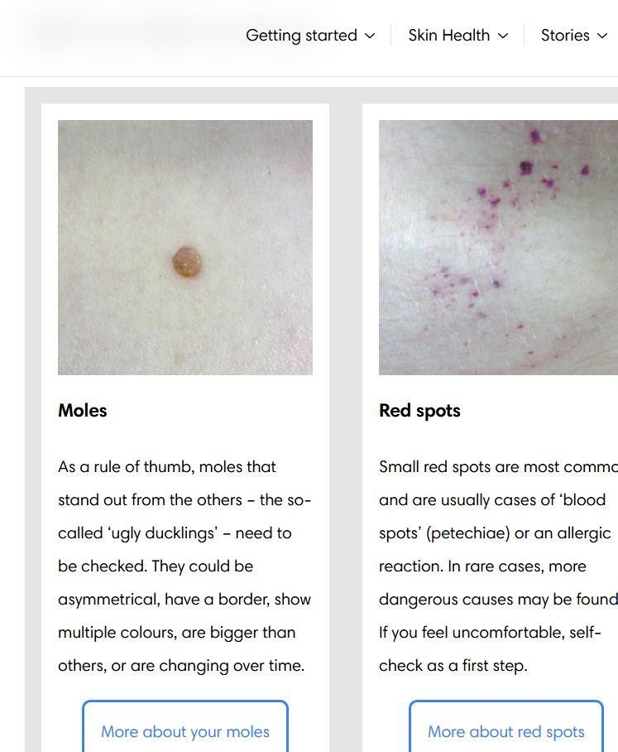

      - Introduction

SkinVision is a commercial mobile application that uses AI to assess skin spots and track changes over time. It's one of the most widely adopted skin screening apps globa ly, available on both iOS and Android platforms.

Working Model

Users photograph skin lesions using their smartphone camera. The AI algorithm analyzes the image and assigns a risk level (low, medium, or high risk). The app also provides tracking features to monitor lesions over time for changes.
Results can be shared with healthcare providers through the app.

Advantages:

CE-marked as a medical device in Europe, providing regulatory credibility

Simple mobile interface with guided photo capture Longitudinaltracking of lesions over time
Integration with healthcare providers for consultation

Disadvantages:

Operates as a black box—provides risk assessment without explaining reasoning

Requires subscription ($30-40/year) which may be prohibitive in developing countries

Internet connectivity required for analysis

No visual heatmaps or specific feature identification Limited transparency in what the AI examines

Summary & Skintelli Contribution

While SkinVision offers convenient mobile screening, it lacks the explainability features central to Skinte li. Users receive risk scores without understanding why. Skinte li differentiates by providing both visual (Grad-CAM heatmaps) and textual explanations, operates offline, and targets desktop deployment for broader accessibility in clinical or community health settings.

Aysa (VisualDx AI Skin Assistant)

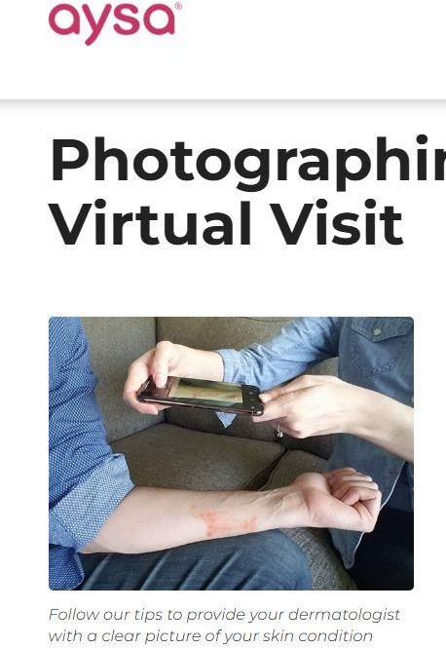
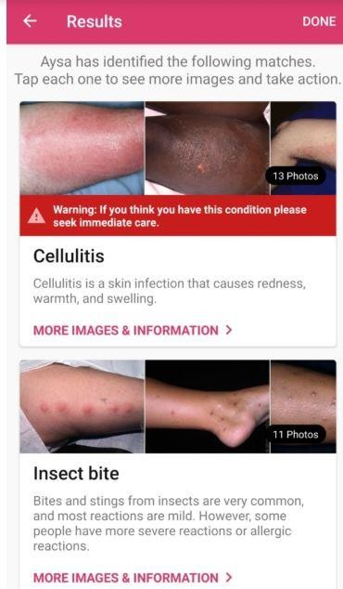

      - Introduction

Aysa is an AI-powered mobile dermatology assistant developed by VisualDx, designed to help users identify possible skin conditions by analyzing uploaded images. It provides condition suggestions based on one of the largest curated dermatology image databases in the world, making it a powerful patient-facing diagnostic support tool.

      - Working Model
Aysa uses deep learning and the VisualDx medical image dataset to evaluate images of rashes, moles, or lesions.
The system matches the uploaded photo with thousands of clinically validated skin images and presents a list of possible conditions, along with descriptions, symptoms, and recommended next steps.
Advantages
        - Uses a clinically validated, dermatologist-reviewed database
        - Provides simple, patient-friendly explanations
        - Works on mobile devices and requires no medical expertise
        - Supports a wide variety of skin conditions

        - Helps users decide whether they need professional care Disadvantages
        - Does not provide visual heatmaps or explain why the model made a prediction
        - Limited precision for rare or complex conditions
        - Works only as a guidance tool—not a diagnostic system
        - Requires internet access for full functionality
        - Not optimized for offline or low-resource environments

Summary & Skintelli Contribution

Aysa is a strong patient-facing AI tool for suggesting possible skin conditions using clinical image matching. However, unlike Skintelli, it does not provide explainable heatmaps or transparent decision reasoning, and it relies on internet connectivity.
Skintelli builds upon these limitations by offering offline capability, visual heatmaps (Grad-CAM), natural- language explanations, and RAG-supported medical grounding, making it more suitable for community clinics and low-resource environments.

    - SkinSight

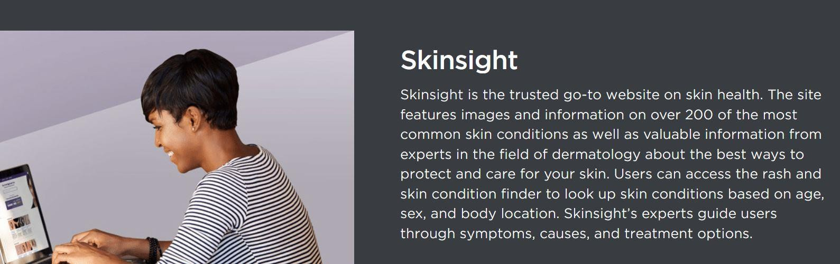

Introduction

SkinSight, also known as Google Dermatology Assist, is an AI-powered web-based application developed by Google Research for preliminary skin condition assessment. The platform combines user-provided symptom data with multiple uploaded skin images to suggest possible dermatological conditions, demonstrating Google’s advances in medical imaging and explainable AI for patient-centered dermatology support.

Working Model

SkinSight guides users through a structured process where they first answer questions regarding their skin concerns, such as symptom details, duration, and affected areas. Users then upload two to three photos of the affected skin from different angles. The AI model integrates this multimodal input to generate a ranked list of potential skin conditions. In addition to diagnostic suggestions, SkinSight presents educational content, including example images and condition descriptions, sourced from validated dermatological databases to support user understanding.

Advantages

        - Utilizes multiple images and symptom-based queries for richer contextual analysis
        - Provides visual reference images from curated dermatology datasets
        - Accessible as a web-based platform with no need for app installation
        - Developed and backed by Google’s extensive AI research capabilities
        - Offers educational resources to enhance user comprehension of suggested conditions Disadvantages
        - Primarily a research-phase tool with limited clinical deployment
        - Requires continuous internet connectivity for full functionality
        - Explanations rely on matching examples rather than revealing AI decision pathways
        - Lacks visual attention mechanisms such as Grad-CAM to illustrate model focus
        - Deployment and accessibility in low-resource settings remain uncertain

Summary & Skintelli Contribution

SkinSight showcases the promise of integrating AI with symptom data for dermatological screening but remains largely educational and example-based without transparent insight into AI reasoning. Conversely, Skintelli delivers an explainable, offline-capable system that explicitly visualizes diagnostic focus through Grad-CAM heatmaps and clarifies reasoning with large language model–generated natural language explanations. This transparency, combined with Skintelli’s offline desktop design, positions it as a more practical and trustworthy tool for underserved and resource-constrained environments where internet access is limited and user trust is essential.

DermNet
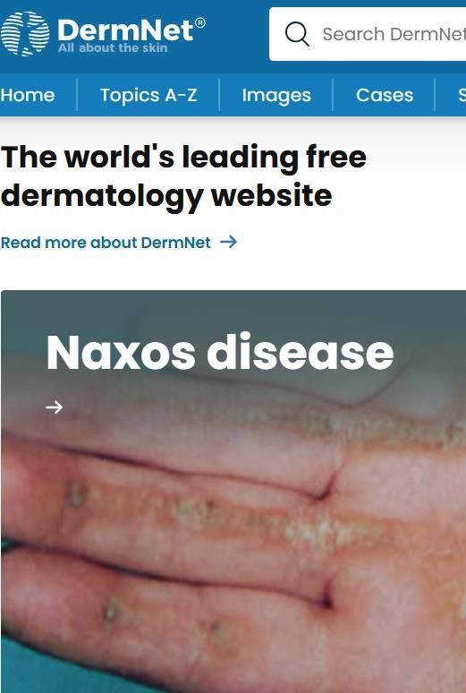
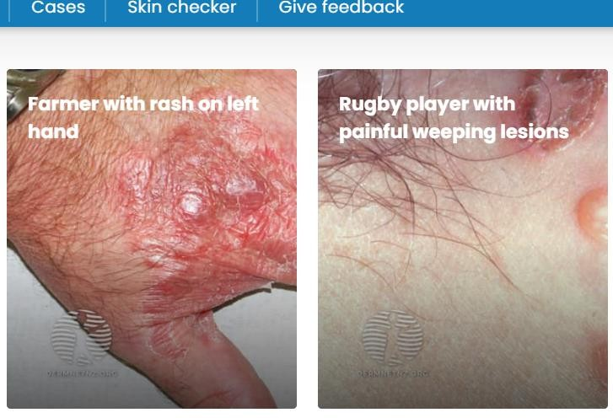

      - Introduction

PACS represents the established standard for medical image management in hospitals worldwide. These systems store, retrieve, and distribute medical images including dermatological photographs, though they traditiona ly lack AI analysis capabilities.

Working Model

Healthcare providers capture medical images using various devices, which are stored in centralized PACS databases. Radiologists and specialists access these images through dedicated workstations for diagnosis. Modern PACS increasingly integrate AI-powered analysis tools as plugins.

Advantages:

Industry standard with proven reliability

Comprehensive image management and archiving Integration with hospital information systems
Secure and HIPAA-compliant

Supports collaboration among specialists

Disadvantages:

No native AI diagnostic capabilities (requires third-party integration) Extremely expensive infrastructure (hundreds of thousands of dollars) Requires trained IT staff for maintenance
Not designed for patient-facing use

No explainable AI features in traditional systems

Completely impractical for sma l clinics or community health centers

2.2.4.4. Summary & Skintelli Contribution

PACS serves an entirely different use case—institutional image management rather than point-of-care diagnosis. Skinte li complements rather than competes with PACS by offering accessible screening capabilities outside hospital settings.
Where PACS requires massive infrastructure, Skinte li needs only a modest computer. Where PACS is clinician- focused, Skinte li empowers patients and community health workers.

    - MoleScope / DermLite

      - Introduction
MoleScope and DermLite are dermoscopy devices—specialized cameras with magnification and specific lighting used by dermatologists for detailed skin examination. Some models now incorporate AI analysis features.

Working Model

These devices attach to smartphones or work as standalone units, capturing high-quality magnified images of skin lesions. Advanced models include AI algorithms that analyze dermoscopic features and provide risk assessments. Images can be stored and tracked over time.

Advantages:

Superior image quality compared to regular phone cameras Used by medical professionals, providing clinical credibility Exce lent for tracking lesion changes
Some models include AI analysis capabilities

Disadvantages:

Expensive hardware ($400-$2000+), inaccessible to average consumers AI features (when present) typica ly lack explanation mechanisms
Requires training to use properly
Not suitable for mass community screening

Proprietary systems with limited interoperability

Summary & Skintelli Contribution

DermLite/MoleScope devices excel at image capture but require significant investment. Skinte li works with standard cameras available on any computer, removing hardware barriers. More critica ly, even AI-enabled dermoscopy tools rarely explain their reasoning—they provide risk scores without transparency. Skinte li's explainable approach makes it complementary to these devices; dermoscopy images could be analyzed through Skinte li for transparent assessment.

Analysis Table

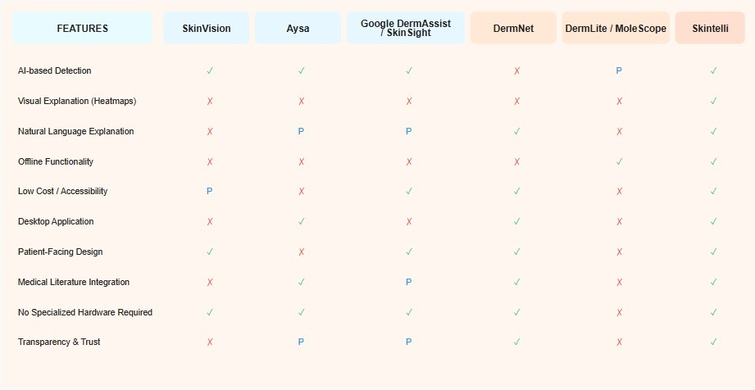
✓ = Yes / Fu ly Supported

✗ = No / Not Supported

P = Partial Support or limited implementation

Working Models for Skintelli

Skinte li's architecture is built on several integrated working models that define its functionality and value proposition:

Explainable AI Model: This is Skinte li's core innovation. Rather than simply outputting a diagnosis, the system generates multi-layered explanations—visual heatmaps showing spatial reasoning and natural language descriptions

explaining feature-based reasoning. This dual-modality explanation approach addresses both visual and cognitive

learning styles.

Modular AI Pipeline Model: The system follows a clear pipeline: Image Input → YOLOv8 Detection → Grad- CAM Visualization → LLM Explanation Generation → RAG Knowledge Retrieval → Result Presentation. This modularity a lows for future upgrades to individual components without redesigning the entire system.
Trust-Building Through Transparency Model: Every aspect of the interface is designed to build user trust. By showing users exactly what the AI examines (heatmaps) and explaining why certain features matter (LLM), Skinte li transforms AI from a mysterious oracle into an understandable assistant.
Offline-First Architecture: Unlike cloud-dependent systems, Skinte li operates entirely loca ly after deployment. This model ensures privacy (images never leave the user's device), accessibility (works without internet), and cost- effectiveness (no ongoing cloud fees).
Screening Assistant, Not Diagnostic Tool: Skinte li explicitly positions itself as a screening assistant to guide decisions about seeking professional care, not as a replacement for dermatologists. This model manages expectations while maximizing utility within appropriate ethical boundaries.
These working models collectively define Skinte li as a transparent, accessible, and trustworthy AI screening tool for resource-constrained healthcare settings.

Advantages of Skintelli

Based on its design and intended functionalities, Skinte li offers several key advantages:

Transparency & Trust: The primary advantage is explainability—users understand not just what the AI concluded, but why. This addresses the critical trust deficit in medicalAI.
Accessibility in Low-Resource Settings: Offline functionality, minimal hardware requirements, and no recurring costs make Skinte li viable where commercial solutions fail.
Dual-Modality Explanations: Combining visual heatmaps with natural language descriptions accommodates different user preferences and learning styles, maximizing comprehension.

Early Detection Potential: By lowering barriers to screening, Skinte li can catch potentia ly serious conditions earlier, when treatment is most effective and least expensive.
Privacy Preservation: Offline processing means patient data never leaves their device, addressing privacy concerns particularly important in healthcare.
Educational Value: Beyond screening, Skinte li educates users about skin lesion features, improving general health literacy.

Scalability: Desktop deployment a lows use in community health centers, schools, or mobile health camps— multiplying impact beyond individual users.
Research Contribution: Demonstrates a practical implementation of explainable AI in medicine, contributing to the broader field of transparent medical AI systems.

Potential Challenges and Limitations for Skintelli

While Skinte li addresses important needs, acknowledging limitations is crucial for realistic evaluation:

Medical Validation Requirements: While targeting 90%+ accuracy, real-world performance validation with diverse skin types and conditions requires extensive clinical testing beyond typical FYP scope.
Liability and Ethical Concerns: Even clearly labeled as a screening tool, there's risk of users treating results as definitive diagnoses. Clear disclaimers and user education are critical.
Dataset Limitations: Training on HAM10000 and ISIC datasets may not fu ly represent the diversity of skin types, particularly darker skin tones historica ly underrepresented in medical imaging datasets.
Explanation Accuracy: Grad-CAM heatmaps show where the AI looked but don't guarantee those regions are the medica ly relevant ones—validation requires expert dermatologist review.
LLM Hallucination Risk: Despite RAG grounding, language models can sti l generate plausible but incorrect medical information. Rigorous testing and validation of explanations is essential.
Hardware Accessibility: While less demanding than cloud systems, requiring a computer with 4GB RAM may stil be a barrier in extremely resource-limited communities.

Image Quality Dependency: System performance degrades with poor lighting, focus, or image quality—factors difficult to control in non-clinical settings.

Limited Scope: FYP focuses on detection and explanation; future integration with telemedicine, patient records, or treatment recommendations requires significant additional development.

Maintenance and Updates: Medical knowledge evolves; the system requires periodic updates to RAG knowledge base and potential model retraining—beyond FYP scope but critical for long-term deployment.

2.7 Concluding Summary: Skintelli – A Transparent and Accessible Contribution to Medical AI

Skintelli emerges as a thoughtfully designed initiative that addresses a critical gap at the intersection of healthcare accessibility and AI transparency. As demonstrated throughout this chapter, most existing AI-powered skin disease assessment systems primarily emphasize detection accuracy while offering limited or no explainability. This results in black-box solutions that users can neither fully understand nor confidently trust. At the same time, a large population in developing regions continues to face limited access to dermatological expertise, leading to delayed diagnosis and avoidable health complications.

The reviewed systems—SkinVision, Aysa (VisualDx), Google DermAssist, DermNet, and DermLite/MoleScope— each provide value within their respective domains. SkinVision and Google DermAssist offer AI-based assessments through mobile or web platforms, Aysa focuses on image matching and patient guidance, DermNet serves as a highly trusted educational and medical reference resource, and DermLite/MoleScope delivers clinically reliable dermoscopic imaging through specialized hardware. However, despite their strengths, none of these systems provide a fully integrated solution that combines AI-based detection, visual explainability, natural language reasoning, offline accessibility, and low hardware requirements.

The primary contribution and novelty of Skintelli lie in its unique combination of the following features:

High-Accuracy Detection: Utilization of the YOLOv8 object detection model, trained to achieve over 90% accuracy in identifying multiple skin lesion types with rapid processing time.

Visual Explainability: Integration of Grad-CAM heatmaps that visually highlight the specific regions of skin images influencing the AI’s decision, allowing users to verify and understand the system’s focus.

Natural Language Explanations: Use of large language models to translate technical visual features into clear, patient-friendly explanations understandable by non-medical users.

Grounded Medical Knowledge: Retrieval-Augmented Generation (RAG) ensures that explanations are anchored in established dermatological literature, reducing misinformation and increasing reliability.

Automated Intelligent Workflow: Agentic AI manages the complete pipeline—from image input to diagnosis explanation—without requiring technical expertise from the user.

Accessibility-First Design: An offline desktop application that operates without internet connectivity and does not require specialized hardware, making it suitable for resource-constrained environments.

By integrating these capabilities, Skintelli directly addresses the dual challenges of healthcare inaccessibility and AI opacity. Unlike black-box systems, Skintelli emphasizes transparency as a core design principle, recognizing that

an explainable and understandable system is more valuable in medical contexts than a marginally more accurate but opaque alternative.

For patients in rural Pakistan and similar settings, Skintelli provides an accessible preliminary screening tool that was previously unavailable. For community health workers, it serves as a transparent decision-support system that enhances screening capacity. From a research perspective, Skintelli demonstrates that explainability, accessibility, and technical sophistication can coexist within a single medical AI system.

While challenges remain—including clinical validation, dataset diversity, and ethical considerations—the structured and explainability-focused design positions Skintelli as a meaningful contribution to the field of medical AI. As a Final Year Project, Skintelli reflects a strong integration of technical expertise in computer vision and explainable AI with a deep understanding of real-world healthcare needs, ultimately showcasing a responsible and human-centered approach to medical technology.

References SkinVision.
AI-Based Skin Cancer Detection Application.(https://www.skinvision.com)

VisualDx – Aysa AI Skin Assistant.
AI Dermatology Assistant for Patient Guidance.(https://www.visualdx.com/aysa)

SkinSight (Google Dermatology Assist).
AI-Powered Web-Based Skin Condition Assessment Tool.(https://blog.google/technology/health/derm-assist)

DermNet New Zealand.
Trusted Dermatology Education and Clinical Reference Resource.(https://dermnetnz.org)

DermLite.
Dermoscopy Devices for Professional Skin Examination.(https://dermlite.com)

Faculty of Engineering Sciences and Technology

Activity # 03

Course: | Final Year Project 1 | Coordinator: | Dr. Atiya Masood
Marks  Allocated: | 10 Marks | Time Allocated: | 20/12/2025
CLO Allocated: | CLO-1 (BT Level- C3), CLO-2 (BT Level- C4), CLO-3  (BT Level- C5), CLO-5 (BT Level- P4), CLO-8 (BT  Level- A2) | PLO  (GA)Allocated: | PLO1(GA2)- Engineering Knowledge/Knowledge for Solving Computing Problem, PLO2(GA3)- Problem Analysis, PLO 5(GA5)- Modern Tool Usage and PLO 10(GA7)- Communication
Requirement Identifying Techniques

To derive the functional requirements for Skintelli, we utilized Document Analysis (analyzing medical dermatological standards and existing AI-based diagnostic systems), User Stories from the perspective of patients in rural areas lacking dermatological access, and Stakeholder Interviews (engaging with healthcare professionals and potential users). This ensured the system addresses the core problem of limited dermatologist access in Pakistan and lack of trust in AI systems due to unexplained predictions.

2. Functional Requirements:

This section describes the functional requirements of the system expressed in natural language style. This section is typically organized by feature as system feature name and specific functional requirements associated with this feature.
Feature 1: User Authentication & System Access:
Table 1: User Login

Identifier | Req 1
Title | User Login
Requirement | The user shall be able to access the Skintelli desktop application without requiring internet connectivity for core diagnostic  functions.
Business Rule (if  required) | The system operates offline to ensure accessibility in areas with limited internet.
Table 2: Application Launch

Identifier | Req 2
Title | Application Launch
Requirement | Upon launching the application, the system shall display the main interface with options for image capture, image upload,  and accessing previous results.
Business Rule (if  required) | N/A

2: Image Input & Capture:
Feature

Table 3: Camera Image Capture

Identifier | Req 3
Title | Camera Image Capture
Requirement | The user shall be able to capture a skin lesion image directly using a connected camera device through the application  interface.
Business Rule (if required) | Image must meet minimum quality  standards (resolution, lighting) for accurate analysis.

Table 4: Image File Upload

Identifier | Req 4
Title | Image File Upload
Requirement | The user shall be able to upload pre- existing skin lesion images from their local storage in common formats (JPEG,  PNG, BMP).
Business Rule (if  required) | Maximum file size: 10MB; supported formats: JPEG, PNG, BMP.

Table 5: Image Preview

Identifier | Req 5
Title | Image Preview and Confirmation
Requirement | Upon capture or upload, the system shall display a preview of the selected image before proceeding with analysis.
Business Rule (if required) | User must confirm the image before analysis begins.

Feature 3: YOLOv8-Based Lesion Detection:

Table 6: Skin Lesion Detection

Identifier | Req 6
Title | Skin Lesion Detection
Requirement | The system shall use the trained YOLOv8 model to detect and localize skin lesions within the uploaded/captured image within 5 seconds.
Business Rule (if required) | Detection accuracy must be ≥90% based on test dataset validation.

Table 7: Disease Classification

Identifier | Req 7
Title | Disease Classification
Requirement | The system shall classify the detected skin lesion into one of the predefined disease categories (e.g., melanoma, basal cell carcinoma, benign keratosis, etc.) based on  the YOLOv8 model output.
Business Rule (if  required) | Classification must include confidence score displayed to the user.

Table 8: Multiple Lesion Detection

Identifier | Req 8
Title | Multiple Lesion Detection
Requirement | If multiple skin lesions are present in a single image, the system shall detect and classify each lesion separately.
Business Rule (if required) | Maximum 5 lesions can be analyzed per image.

Feature 4: Grad-CAM Visual Explanation:

Table 9: Generate Heatmap Visualization

Identifier | Req 9
Title | Generate Heatmap Visualization
Requirement | The system shall generate a Grad-CAM heatmap overlay on the original image, highlighting the regions that the AI model  focused on for making its prediction.
Business Rule (if required) | Heatmap colors: red/orange indicate high attention areas, blue/green indicate low  attention areas.

Table 10: Dual-Panel Display

Identifier | Req 10
Title | Dual-Panel Display
Requirement | The system shall display the original input image and the Grad-CAM heatmap side- by-side in a dual-panel interface for easy comparison.
Business Rule (if required) | Both panels must be of equal size and synchronized for zoom/pan operations.

Table 11: Heatmap Legend

Identifier | Req 11
Title | Heatmap Legend Display
Requirement | The system shall provide a color-coded legend explaining the heatmap intensity scale to help users interpret the visualization.
Business Rule (if required) | N/A

Feature 5: LLM-Based Natural Language Explanation:

Table 12: Generate Disease Description

Identifier | Req 12
Title | Generate Disease Description
Requirement | The system shall use a Large Language Model (LLM) to generate a user-friendly, natural language description of the detected skin condition, including symptoms, severity indicators, and general information.
Business Rule (if required) | Explanation must be in simple, non-technical language suitable for general users. Maximum  200 words.

Table 13: Display Confidence Level

Identifier | Req 13
Title | Display Confidence Level
Requirement | The system shall clearly display the AI model's confidence level (percentage) for the prediction alongside the natural  language explanation.
Business Rule (if required) | Confidence levels below 70% should trigger a disclaimer message advising  professional consultation.

Table 14: Medical Disclaimer

Identifier | Req 14
Title | Medical Disclaimer Display
Requirement | The system shall prominently display a medical disclaimer stating that the system is a screening assistant tool only and not a substitute for professional medical diagnosis.
Business Rule (if required) | Disclaimer must be visible on every results screen and cannot be permanently dismissed.

Feature 6: RAG (Retrieval-Augmented Generation) Integration:

Table 15: Access Medical Knowledge Database

Identifier | Req 15
Title | Access Medical Knowledge Database
Requirement | The system shall utilize RAG to retrieve relevant, updated medical information from a curated knowledge database to enhance the accuracy and relevance of generated  explanations.
Business Rule (if  required) | Knowledge database must be updated quarterly with latest dermatological research.

Table 16: Contextual Information Retrieval

Identifier | Req 16
Title | Contextual Information Retrieval
Requirement | When generating explanations, the system shall retrieve context-specific information related to the detected disease type to provide comprehensive guidance.
Business Rule (if required) | Retrieved information must be from verified medical sources only.

Feature 7: Agentic AI Workflow Automation:

Table 17: Automated Analysis Pipeline

Identifier | Req 17
Title | Automated Analysis Pipeline
Requirement | The Agentic AI component shall automatically orchestrate the complete workflow from image input → YOLOv8 detection → Grad-CAM generation → LLM explanation → final result display without manual intervention.
Business Rule (if required) | Entire pipeline must complete within 10 seconds for standard resolution images.

Table 18: Error Handling & Recovery

Identifier | Req 18
Title | Error Handling & Recovery
Requirement | If any component of the analysis pipeline fails, the Agentic AI shall detect the error, log it, and provide a user-friendly error message with suggestions for resolution.
Business Rule (if required) | System must not crash; graceful degradation required for component failures.

Table 19: Progress Indication

Identifier | Req 19
Title | Progress Indication
Requirement | During analysis processing, the system shall display real-time progress indicators showing which stage of pipeline is currently executing (detection, visualization, explanation generation).
Business Rule (if required) | Progress bar must update at least every 2 seconds.

Feature 8: Results Management:

Table 20: Save Analysis Results

Identifier | Req 20
Title | Save Analysis Results Locally
Requirement | The user shall be able to save the complete analysis results including original image, heatmap, classification, confidence score, and explanation to local storage.
Business Rule (if required) | Results saved in PDF format with timestamp and unique identifier.

Table 21: View Analysis History

Identifier | Req 21
Title | View Analysis History

Requirement | The system shall maintain a local history of  previous analyses that users can browse and review with thumbnail previews.
Business Rule (if required) | Maximum 50 most recent analyses stored; older records auto-deleted.

Table 22: Export Results

Identifier | Req 22
Title | Export Results
Requirement | The user shall be able to export analysis results in multiple formats (PDF, JPEG, TXT) for sharing with healthcare professionals.
Business Rule (if required) | Exported files must include medical disclaimer and timestamp.

Feature 9: User Interface & Experience:

Table 23: Intuitive Navigation

Identifier | Req 23
Title | Intuitive Navigation
Requirement | The GUI shall provide clear, labeled buttons and menus for all major functions (capture, upload, analyze, view history,  settings) with intuitive iconography.
Business Rule (if required) | Interface must be usable without technical training; target completion of first analysis within 2 minutes for  new users.

Table 24: Responsive Design

Identifier | Req 24
Title | Responsive Design
Requirement | The application interface shall automatically adjust layout and element sizing based on screen resolution while  maintaining usability.
Business Rule (if required) | Minimum supported resolution: 1024x768; maximum: 4K.

Table 25: Help & Documentation Access

Identifier | Req 25
Title | Help & Documentation Access
Requirement | The system shall provide easily accessible help documentation and tooltips explaining each feature and how to interpret results.
Business Rule (if required) | Help system must be searchable and include illustrated examples.

Non - Functional Requirements:
This section specifies nonfunctional requirements.

- Performance:

PER-1: The YOLOv8 model shall complete skin lesion detection and classification within 5 seconds on hardware with minimum 4GB RAM and standard CPU (no GPU required for deployment).

PER-2: Grad-CAM heatmap generation shall complete within 2 seconds after classification.

PER-3: The complete analysis pipeline (from image input to final display) shall finish within 10 seconds under normal operating conditions.

PER-4: The application shall start up within 5 seconds on supported hardware configurations.

PER-5: The system shall maintain responsive UI (no freezing) during analysis processing by utilizing multi-threading.

- Usability:

USA-1: The application interface shall be intuitive enough that 90% of first-time users can successfully complete an analysis within 5 minutes without external help.

USA-2: All critical functions shall be accessible within 2 clicks from the main screen.

USA-3: Error messages shall be displayed in clear, non-technical language with actionable suggestions for resolution.

USA-4: The dual-panel display (original image + heatmap) shall clearly indicate which panel is which through labels and visual distinction.

USA-5: Text size and contrast shall meet WCAG 2.1 Level AA accessibility standards for readability.

Reliability (REL):

REL-1: The AI model shall maintain ≥90% accuracy on the validation dataset throughout its operational lifetime.
REL-2: The system shall successfully complete analysis for 95% of properly formatted input images without errors.
REL-3: The application shall handle unexpected shutdowns gracefully, preserving any in-progress analysis data where possible.
REL-4: The error handling system shall catch and log all exceptions without causing application crashes.

Security:
SEC-1: All saved analysis results shall be stored locally with appropriate file permissions to prevent unauthorized access.
SEC-2: The system shall not transmit any user data or images over the internet, ensuring complete privacy.
SEC-3: Exported result files shall include watermarks and metadata indicating they are AI-generated screening results, not professional diagnoses.

Maintainability:
MAIN-1: The codebase shall follow Python PEP 8 style guidelines and include comprehensive inline documentation.

MAIN-2: The system architecture shall use modular design allowing individual components (YOLOv8, Grad-CAM, LLM, RAG) to be updated independently without affecting other modules.
MAIN-3: The medical knowledge database (RAG) shall be updatable without requiring application recompilation or reinstallation.

Portability:
PORT-1: The application shall run on Windows 10/11, with potential for future Linux and macOS support.
PORT-2: The system shall not require internet connectivity for core diagnostic functions, enabling use in offline/rural environments.
PORT-3: Minimum hardware requirements: 4GB RAM, dual-core processor, 2GB free disk space.

Use Case Diagram

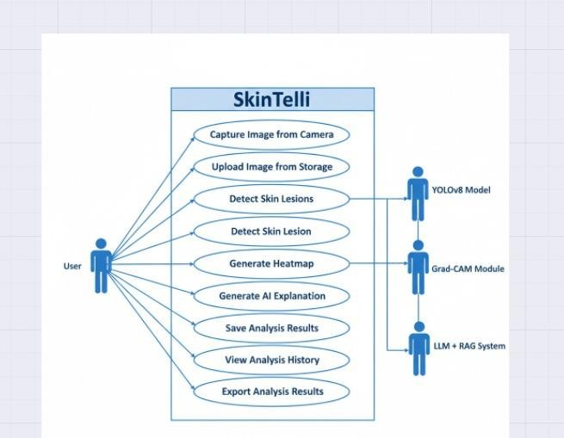

Use Case Diagram: SkinTelli – Skin Lesion Analysis System

The Use Case Diagram illustrates the functional behavior of the SkinTelli system, an AI-based skin lesion analysis application. The diagram represents the interaction between the User and multiple intelligent components integrated within the system, including YOLOv8 Model, Grad- CAM Module, and LLM with Retrieval-Augmented Generation (RAG).

Primary Actor
  - User: The end user who interacts with the system to perform skin lesion analysis, view results, and manage analysis records.

Secondary Actors
  - YOLOv8 Model: Responsible for detecting and localizing skin lesions within the input image.
  - Grad-CAM Module: Generates visual heatmaps highlighting the regions of interest used by the model during classification.
  - LLM + RAG System: Produces human-readable explanations and supports decision- making using medical knowledge sources.

Use Case Descriptions:

- Capture Image from Camera
Allows the user to capture a real-time image of a skin lesion using a camera device for analysis.
- Upload Image from Storage
Enables the user to upload an existing skin image from local storage into the system.
- Detect Skin Lesions
The system processes the input image and identifies suspicious skin lesion regions using the YOLOv8 model.
- Detect Skin Lesion
Performs refined lesion localization and prepares the detected region for further analysis.

- Generate Heatmap
Uses the Grad-CAM module to generate a visual heatmap that highlights important regions influencing the model’s prediction.

- Generate AI Explanation
Produces a natural language explanation describing the detected condition, model decision rationale, and medical relevance using the LLM + RAG system.
- Save Analysis Results
Stores the diagnosis, heatmap, explanation, and confidence score for future reference.
- View Analysis History
Allows the user to review previously saved analysis records.
- Export Analysis Results
Enables exporting of analysis reports in a downloadable format for medical consultation or documentation.

System Significance:

This use case diagram demonstrates how SkinTelli integrates computer vision, explainable AI, and large language models to provide transparent and user-friendly skin lesion analysis. The system ensures interpretability, traceability, and ease of use while supporting informed medical decision-making.

Prototype:
Insert minimum Prototype (Usually 4-6 Prototypes) which show the major modules mentioned in the scope section of the document. Do not include Prototypes for Login, Signup, Forgot Password, Contact Us, About Us etc. If the project is a Web or a Smartphone Application, then include at least three Prototypes from each part of the project

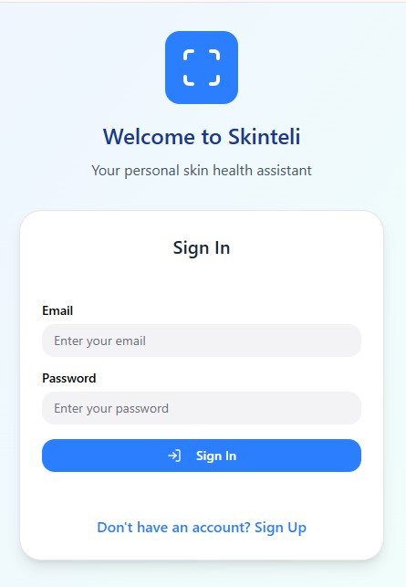
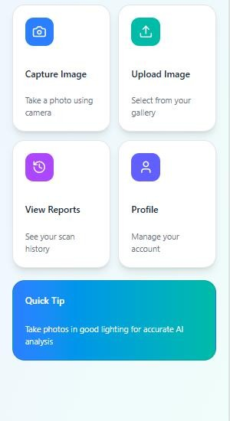
. LOGIN PAGE OR SIGN UP

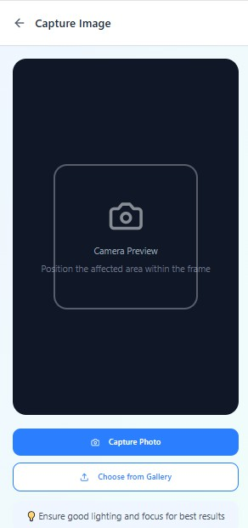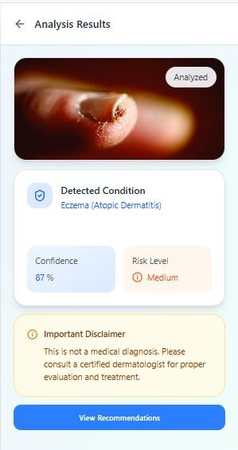

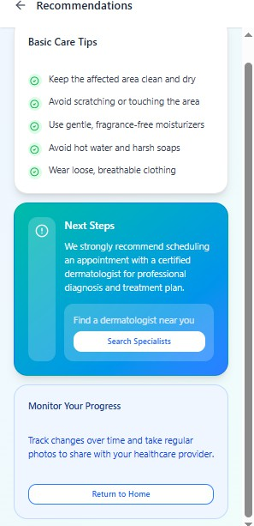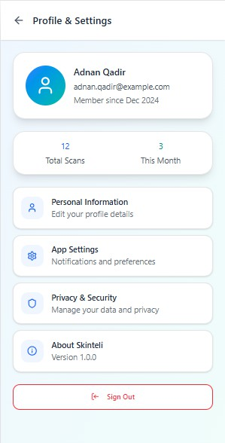

Faculty of Engineering Sciences and Technology

Activity # 04

Course: | Final Year Project 1 | Coordinator: | Dr. Atiya Masood
Marks Allocated: | 10 Marks | Time Allocated: | 30/12/2025
CLO Allocated: | CLO 9, CLO 10 | PLO (GA)Allocated: | GA6, GA7
Proposed Budget

Heads of Expenditure and Additional Charges
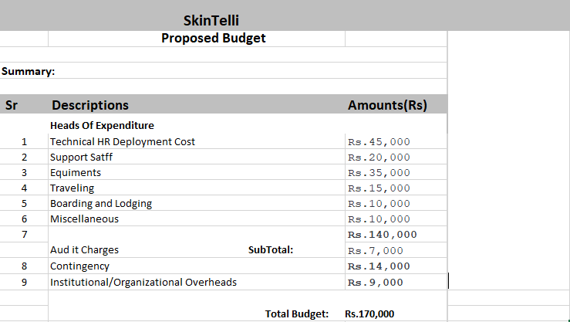
`

Total Budget:
The total budget for this project amounts to Rs.170,000.

Funding Sources:
